Name : Abubaker Attique

Roll No :

P20-0560

Section :

5-A

Lab 02

Task 1 :





**Connection :**

* Open packet tracer
* At the bottom you will see tool bar
* Select the two pc by drag and drop
* Connect the both pc by cross over wire

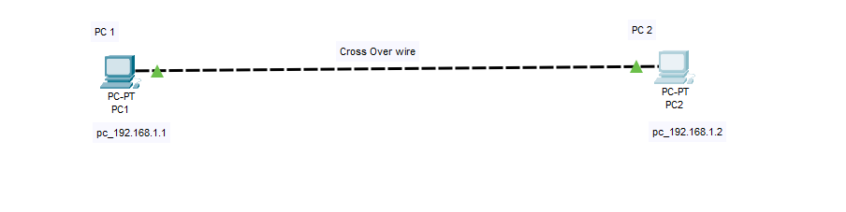

**PC 1 :**

* Click on the pc 1
* Then click on the desktop and open the ipconfigration
* Add the ipv4 address which is 192.168.1.1

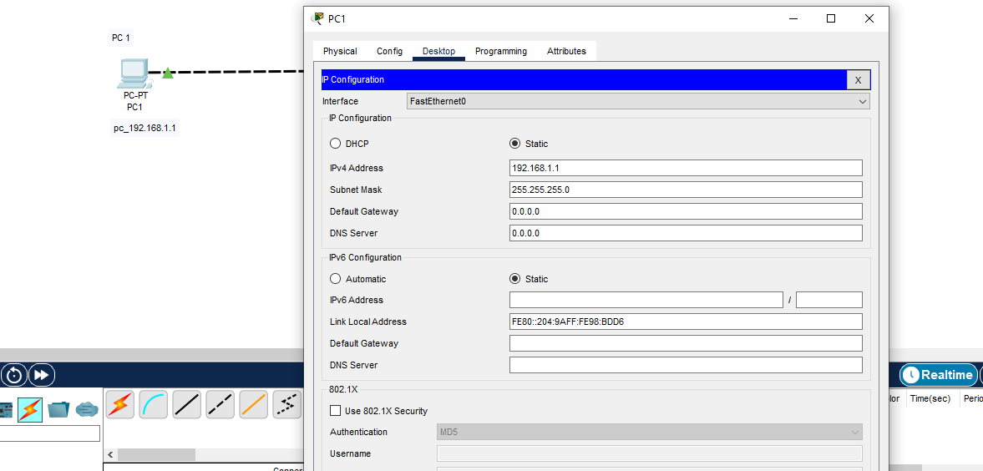

**PC 2:**

* Click on the pc 2
* Then click on the desktop and open the ipconfigration
* Add the ipv4 address which is 192.168.1.2

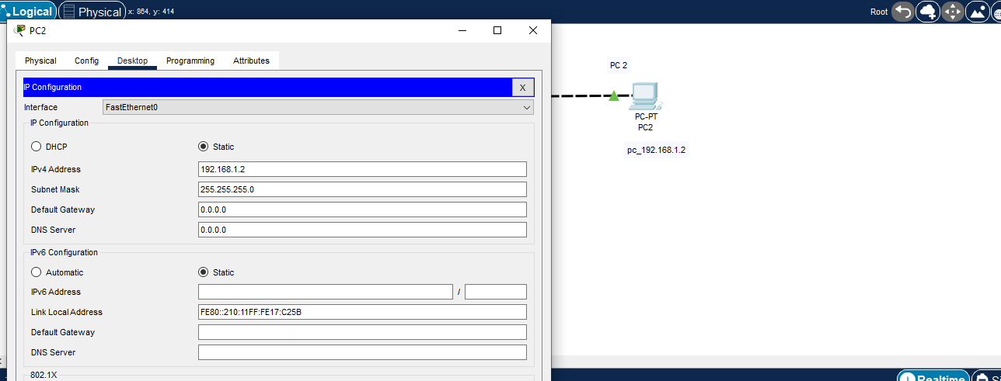

**Ping to check the connection :**

Now to ensure that the connection is established correctly, we will check the connection by clicking at ant pc and then open command promot and then type ping ipv4 address of pc 2 and then enter.

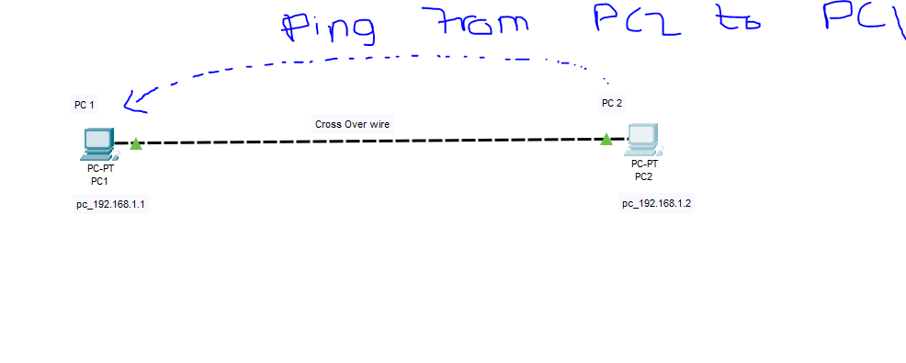

* After this you will see this type of detail if sent == received and there is 0 lost then the connection is Correctly.

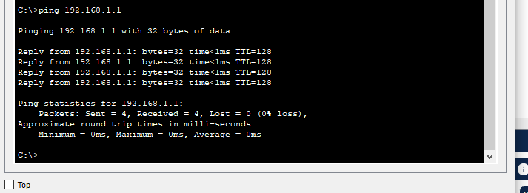

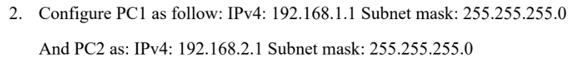

**Ipconfig for Pc1**

* We will give IPv4 192.168.1.1 and subnet mask 255.255.255.0 and the cross.

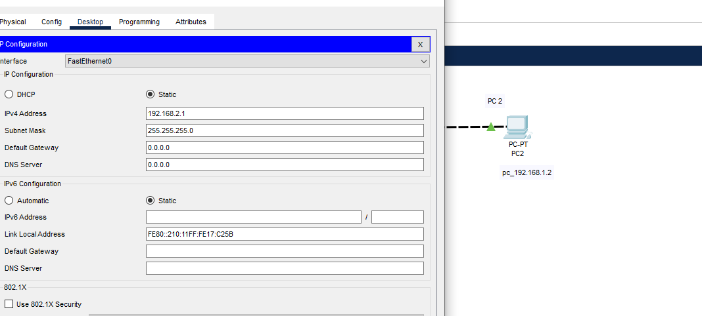

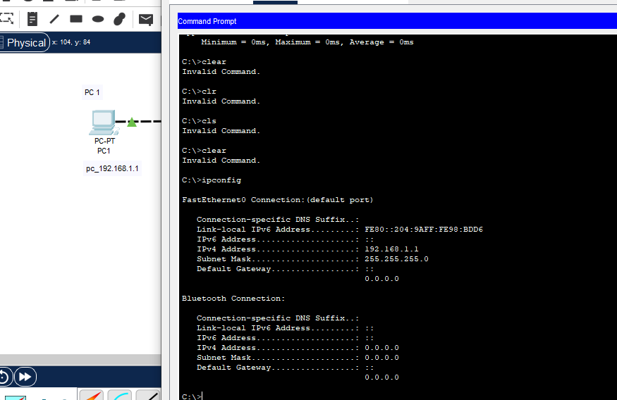

**Ping form pc1 to pc2**

**Issue** :

When we ping from pc1 to pc2 to check the connection and as the below we can see the request time out and the packet are lost this is because the network assign to pc1 is different from pc2 so that’s way this error is giving as a result .

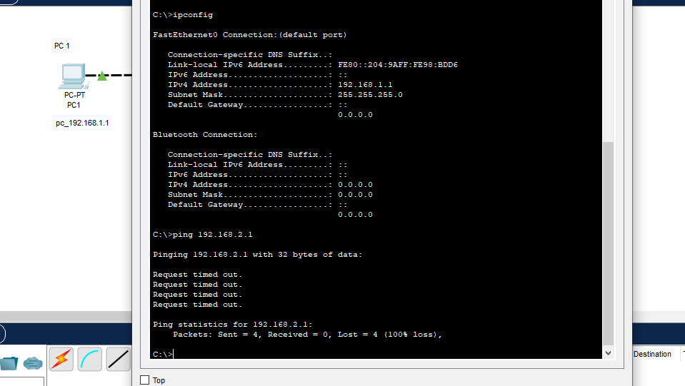

.

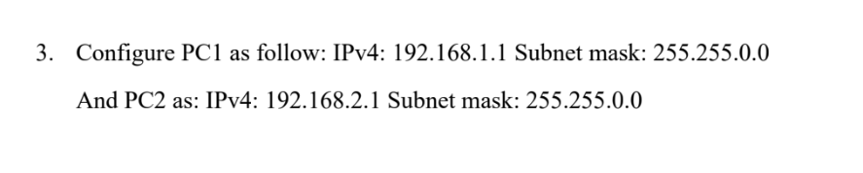

**PC1:**

* Open the ipconfigration to change the IPv4 address to 192.168.1.1 and change the subnet mask to 255.255.0.0

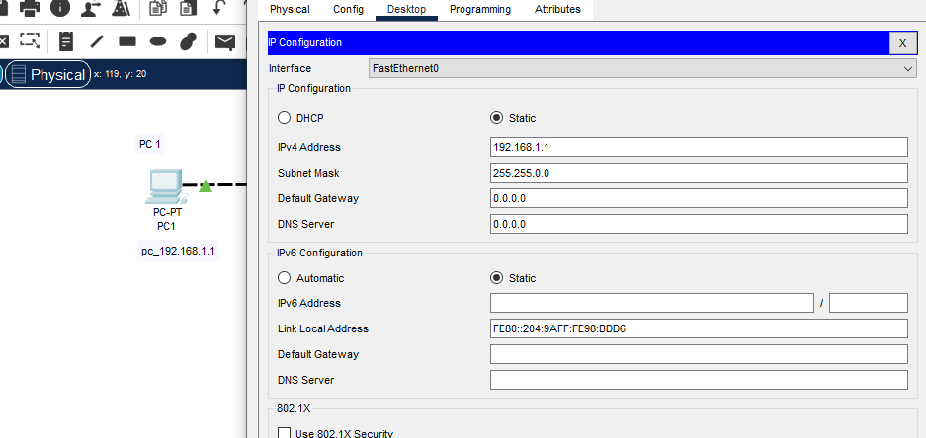

**PC2:**

* Open the ipconfigration to change the IPv4 address to 192.168.2.1 and change the subnet mask to 255.255.0.0 for PC2 .

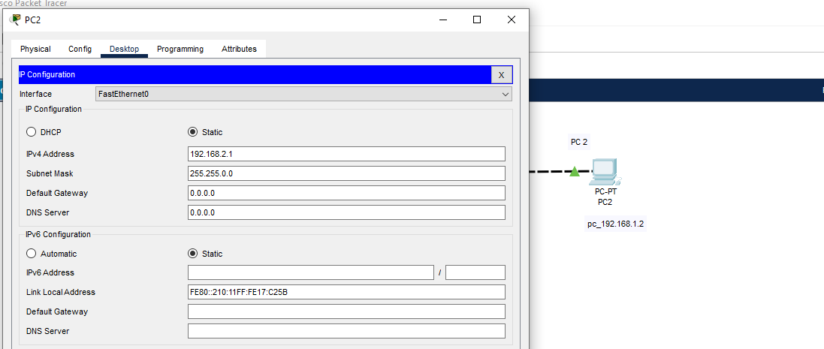

**Ping from pc2 to pc1:**

* Now to check the connection is established or not we will send some data to PC1
* As in the previous task the connection time is out and we lost the packet now this time we change the subnet mask but not the address so it send the data successful this is because we are having the same network.

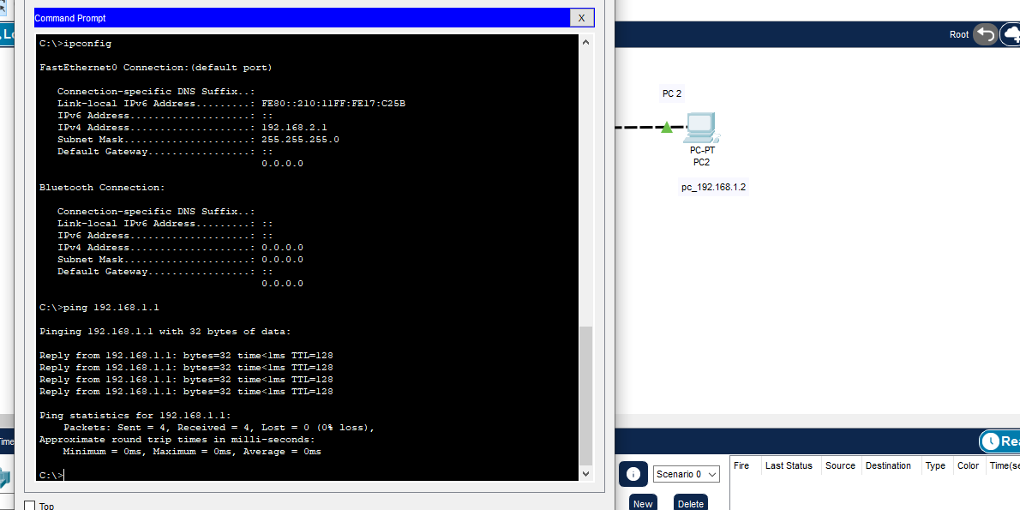

**Ping from pc1 to pc2**

* Now to check the connection is established or not we will send some data to PC2
* As in the previous task the connection time is out and we lost the packet now this time we change the subnet mask but not the address so it send the data successful this is because we are having the same network.

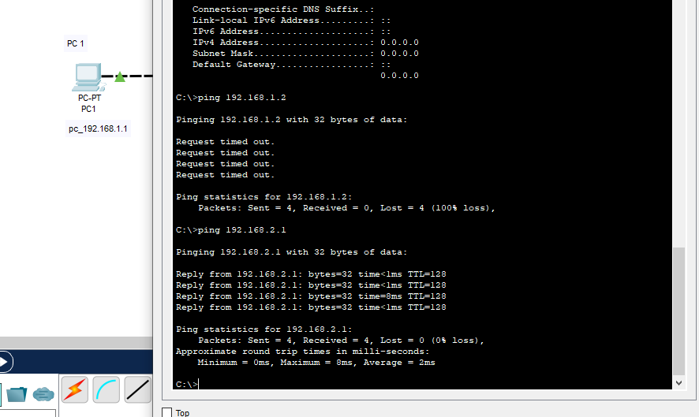

**TASK 2 :**



**Connection for PCS with HUB:**

Connect the PC to the hub with the help of straight through wire, assign IPs to them.

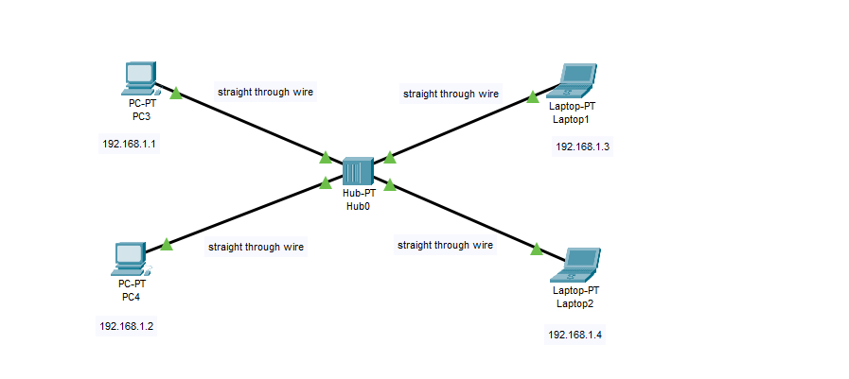

**Message from source to destination :**

* To send packets from one PC to another we need to have the source and the destination to which we are sending the message.

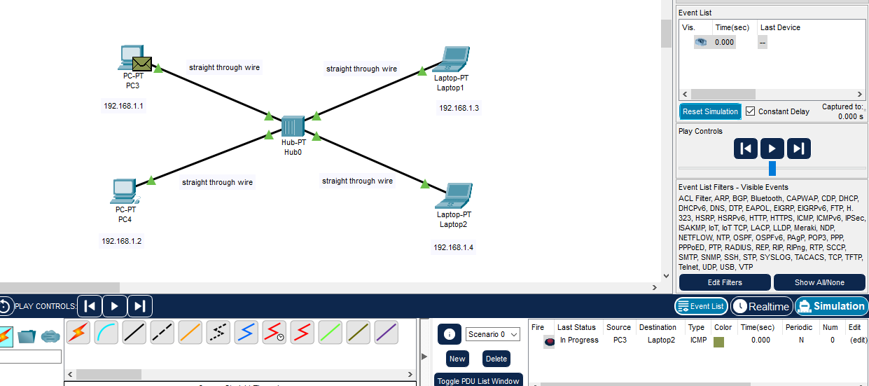

**Packet from Source to HUB :**

* The packet will come from source to hub in the initial step.

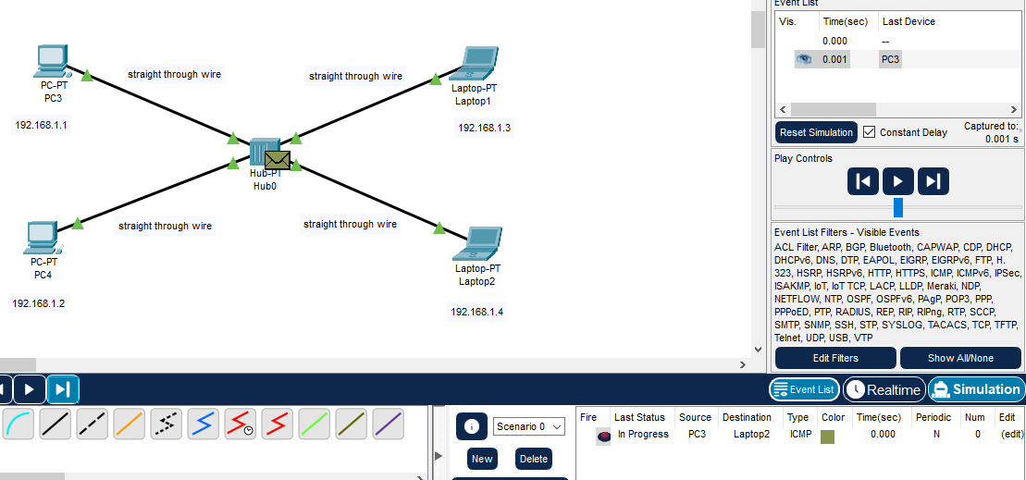

**Broadcasting :**

* Hub will broadcast this packet to all the connection with which it is connected.

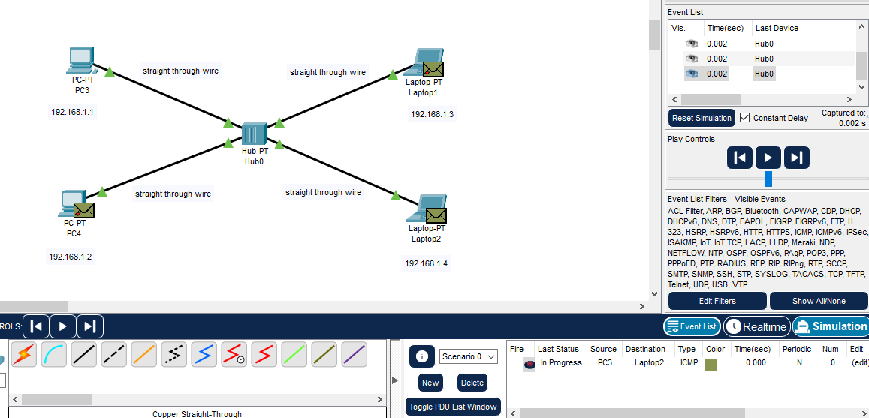

**Destination Received the packet:**

* When the destination laptop received the message then it will again send the message t0 hub as a confirmation message now it is the responsibility of the hub to give message to source pc.

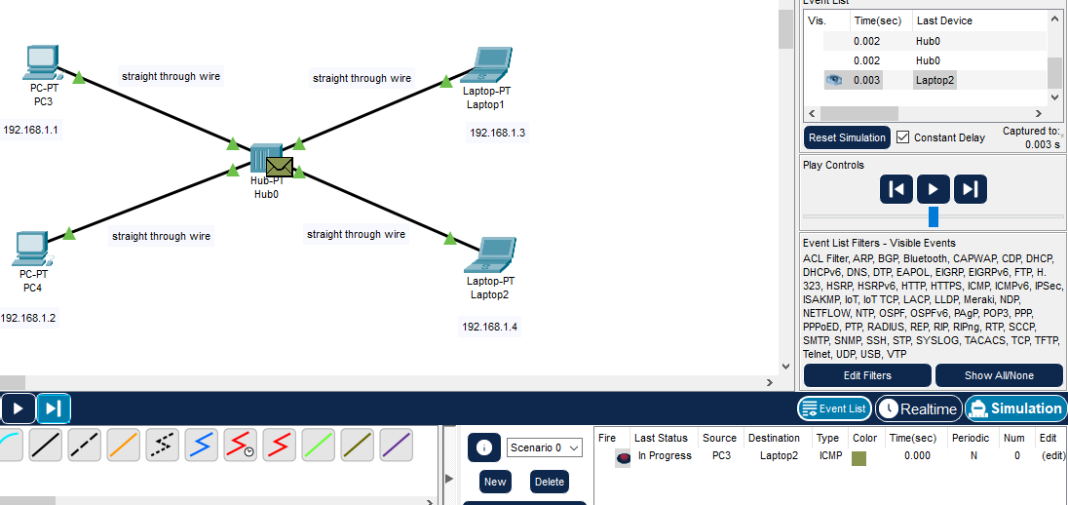

HUB will send again the confirmation to all the connected network, source will accept the confirmation and other will reject the network.

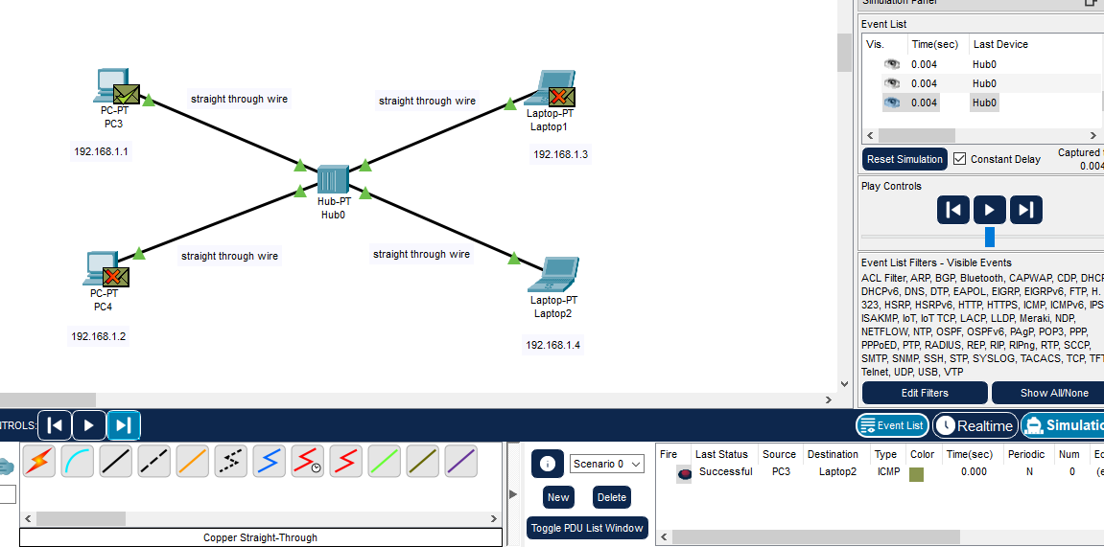

**Task 3**



**SWITCH CONNECTION**

**Connection :**

* Connect the PC and laptop to the switch with the help of straight through

wire, assign IPs to them.

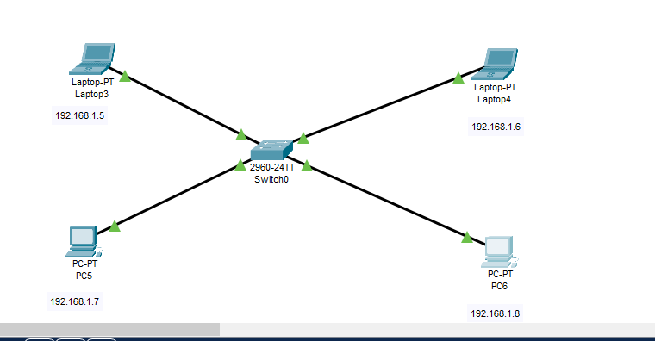

**Message from source to destination :**

* We will send the message from the source to the destination following are the steps :

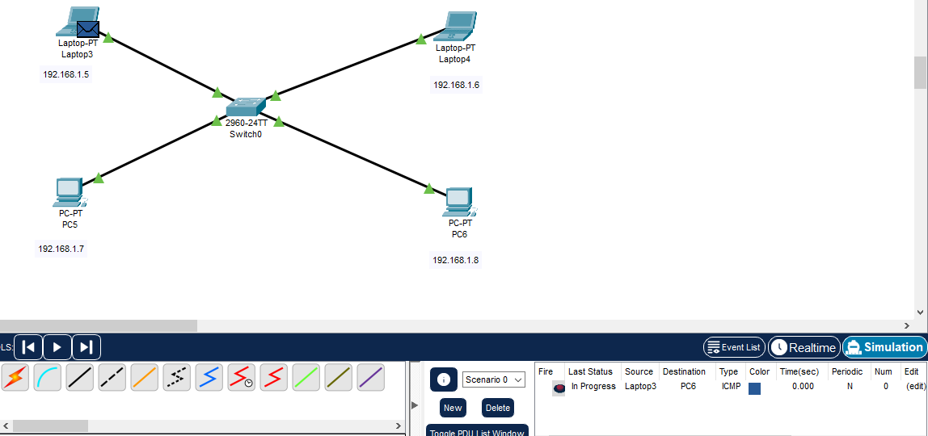

**Source to Switch :**

* From the source the message will be received by the switches and then it will broad cast the message with the connected devices / network.

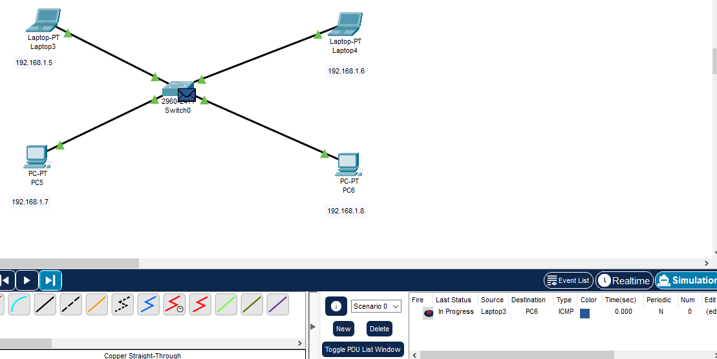

**Broadcasting :**

* Here from the switch the broadcasting will be started to the connected networks

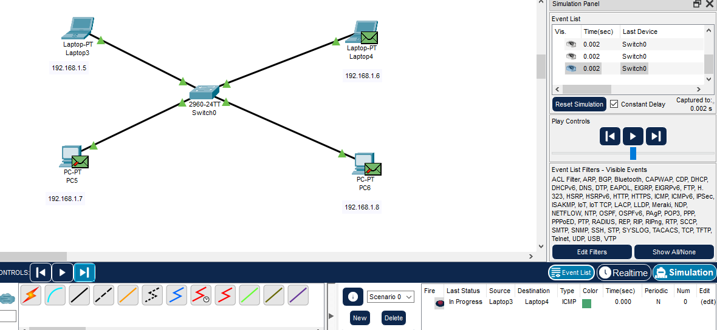

**Reach the destination :**

* When the destination received the message it will again send the confirmation to the switch so after that switch should send the message to source that message has been sent.

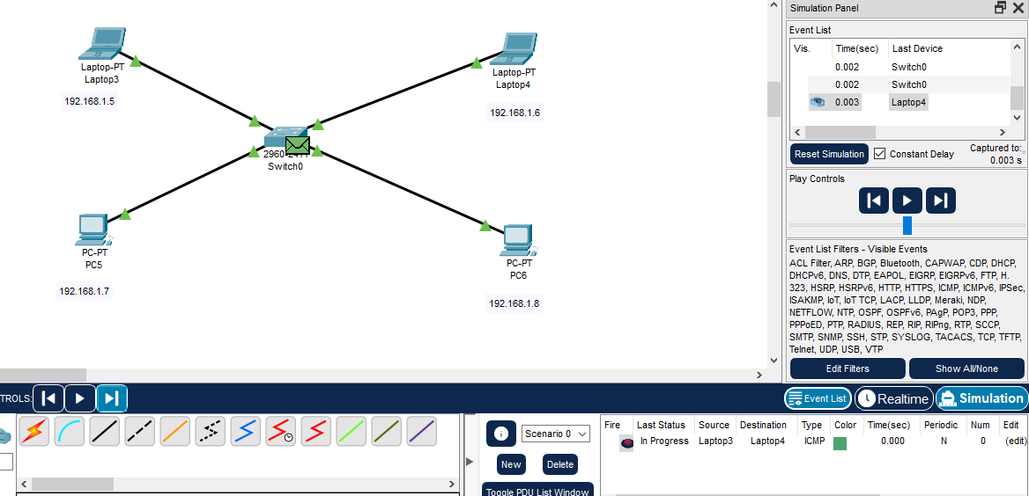

**Confirmation from switch to source :**

